K.S. RANGASAMY COLLEGE OF TECHNOLOGY

(An Autonomous Institution, affiliated to Anna

University Chennai and Approved by AICTE, New Delhi)

TIRUCHENGODE – 637 215



B.E. COMPUTER SCIENCE AND ENGINEERING

**Hostel management system**

**Database Management Systems**

**Mini Project Report**

**Submitted by**

M GUNA (1914117)

(2019-2023 Batch)

November/2021

**TABLE OF CONTENTS**

|  |  |  |
| --- | --- | --- |
| **CHAPTER** | **TITLE** | **Page No.** |
| 1 | Objective  Introduction  ER-Diagram | **3**  **3**  **4** |
| 2 | Modules  Tables  Database Schema  Queries | **4**  **5**  **8**  **8** |
| 3 | Screenshots | **18** |
| 4 | Codings | **28** |
| 5 | Conclusion | **55** |

**CHAPTER 1**

**OBJECTIVE  :**

The main objective behind preparing this project is that to give hostel a complete facility that a hostel managerial team wants. It even helps the user to handle the managing system of the hostel properly. And it also gives the customer an easier way to have booking and other related activities in the hotel. Besides this there are many objectives like:

1. To manipulate the Hostel transactions with instant confirmation.
2. To save time.
3. To increase efficiency of students.
4. For fast access of data.
5. For secure and smooth running of the program.
6. For error free, effective and easy for database related works.
7. The application request for the check-in and check-out date and time, number of visitors, and his/her preferred room category;
8. Indicate the room availability and the location of the rooms;
9. If the visitor is satisfied with the room location, then confirm the booking; and
10. Upon confirmation, print the payment details and other necessary constraints.
11. To reduce material related cost
12. To have an efficient material management a company must establish clear guidelines and strategies regarding purchasing of material, storage and minimization of inventories
13. Good accounting and recording keep will keep a close watch on any workers who might think that they can help themselves with the company's material

**INTRODUCTION :**

With the advancement of technology, application areas of computer are rising day by day. Every sector desires its procurement for fast accurate and automated operations. Therefore different program are developed to meet the requirement of various types of users i.e. related to any field.

This program entitled “**Hostel Management System”** is an individual work of DIT IVth semester student. It is a small software package which is helpful in the areas of Hostel. This program package includes all the activities in which the hostel is managed. The activities like the user management, the inventory processing, the data summary, etc are included.

In terms of security this software is totally secure as it doesn't give access to unauthorized user as the username and password facility is provided.

I chose Hostel management software as the system seemed simple and easy to use. During its development we realized that we needed software that may help to manage hostel activities and various other adjustments.

**ENTITY-RELATIONSHIP DIAGRAM :**

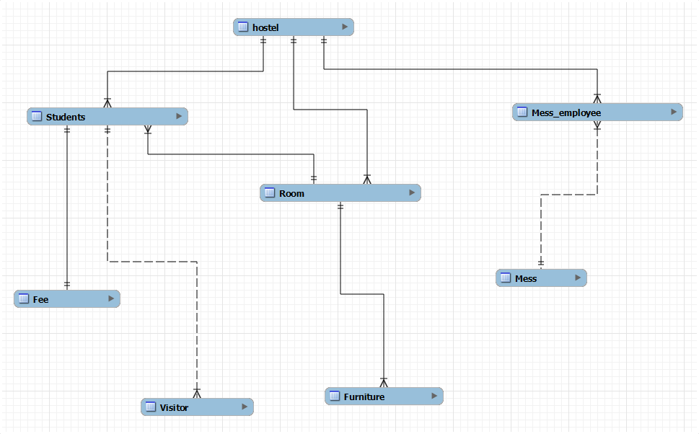

**CHAPTER 2**

**MODULES :**

**1.ADMIN MODULE**

* Add admin,Hostel Manager..
* View Hostel Manager Profile.
* Update new Manager.
* Delete new Manager.
* Admin Activity
* Data Managemen
* Search Student.

**2.HOSTEL MANAGER MODULE**

* View Student Details.
* Search Student Details.
* Student Activity.

**3.STUDENT MODULE**

* Add new Student
* Delete remove Student
* Update Student Profile
* Search Student

**5. HOSTEL MODULE**

* Manage account details of Student
* Manage approved status and send messages
* View Student Profile.
* Manage list of all Students
* Manage all List Furnitures
* Manage all List Mess.

**TABLES :**

**Table 1: Application**

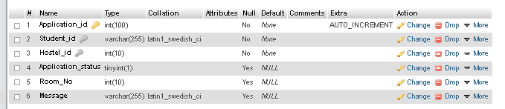

**Table 2: Application_mess**

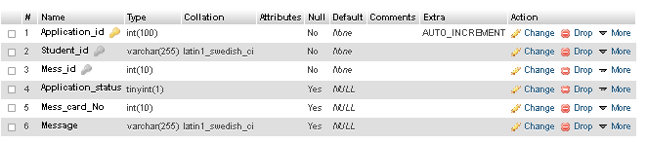

**Table 3: Hostel**

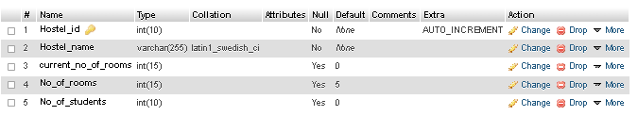

**Table 4: Hostel_Manager**

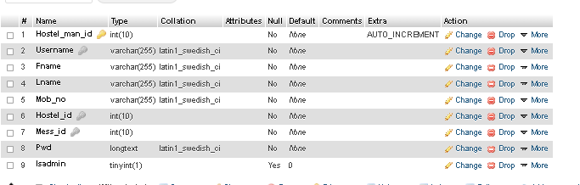

**Table 5: Mess**

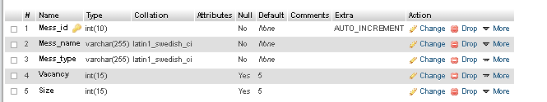

**Table 6: Mess_allocation**

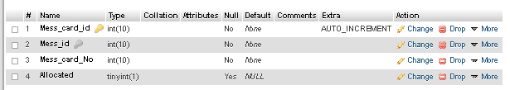

**Table 7: Payment**

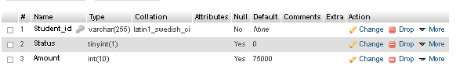

**Table 8: Room**

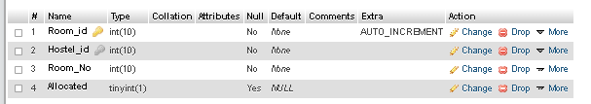

**Table 9: Student**

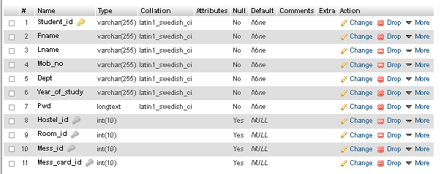

**Table 10 : Hostel_Manager_Profile**

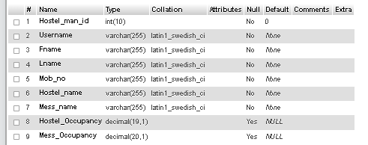

**Database Schema :**

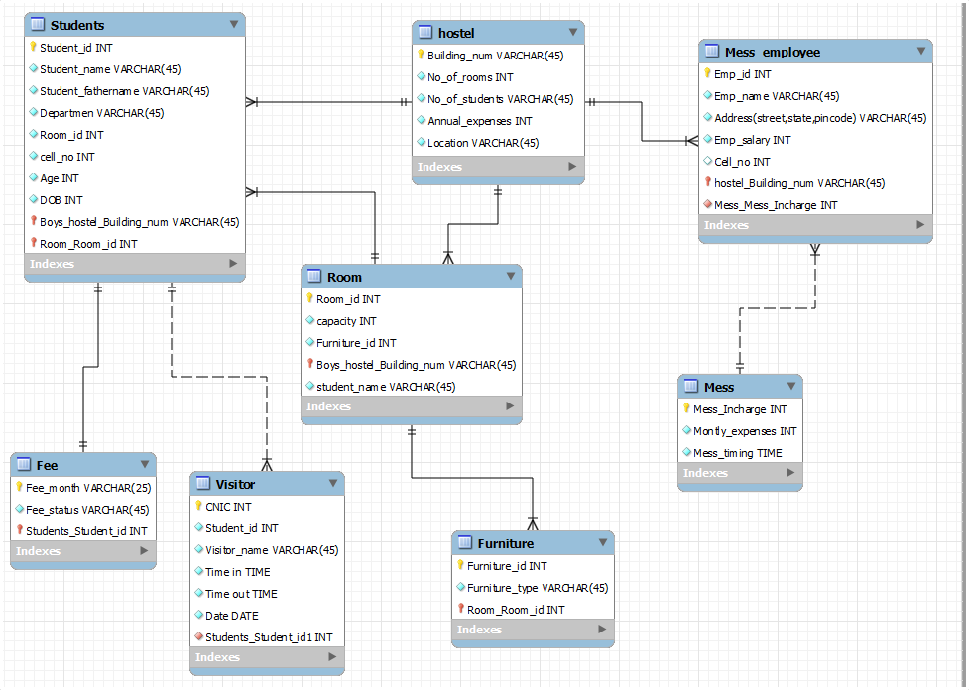

**QUERIES:**

CREATE DATABASE IF NOT EXISTS `hostel_management_system`

USE `hostel_management_system`;

**Table structure for table `Application`**

DROP TABLE IF EXISTS `Application`;

CREATE TABLE `Application` (

`Application_id` int(100) NOT NULL AUTO_INCREMENT,

`Student_id` varchar(255) NOT NULL,

`Hostel_id` int(10) NOT NULL,

`Application_status` tinyint(1) DEFAULT NULL,

`Room_No` int(10) DEFAULT NULL,

`Message` varchar(255) DEFAULT NULL,

PRIMARY KEY (`Application_id`),

KEY `Student_id` (`Student_id`),

KEY `Hostel_id` (`Hostel_id`),

CONSTRAINT `Application_ibfk_1` FOREIGN KEY (`Student_id`) REFERENCES `Student` (`Student_id`),

CONSTRAINT `Application_ibfk_2` FOREIGN KEY (`Hostel_id`) REFERENCES `Hostel` (`Hostel_id`)

) ENGINE=InnoDB AUTO_INCREMENT=17 DEFAULT CHARSET=latin1;

**Dumping data for table `Application`**

LOCK TABLES `Application` WRITE;

INSERT INTO `Application` VALUES (4,'181IT129',3,0,1,''),(5,'181IT130',4,0,1,''),(6,'181IT131',5,0,1,''),(7,'181IT132',6,0,1,''),(8,'181IT206',1,0,2,''),(10,'181IT207',1,0,3,''),(16,'181IT127',1,0,1,'');

UNLOCK TABLES;

**Table structure for table `Application_mess`**

DROP TABLE IF EXISTS `Application_mess`;

CREATE TABLE `Application_mess` (

`Application_id` int(100) NOT NULL AUTO_INCREMENT,

`Student_id` varchar(255) NOT NULL,

`Mess_id` int(10) NOT NULL,

`Application_status` tinyint(1) DEFAULT NULL,

`Mess_card_No` int(10) DEFAULT NULL,

`Message` varchar(255) DEFAULT NULL,

PRIMARY KEY (`Application_id`),

KEY `Student_id` (`Student_id`),

KEY `Mess_id` (`Mess_id`),

CONSTRAINT `Application_mess_ibfk_1` FOREIGN KEY (`Student_id`) REFERENCES `Student` (`Student_id`),

CONSTRAINT `Application_mess_ibfk_2` FOREIGN KEY (`Mess_id`) REFERENCES `Mess` (`Mess_id`)

) ENGINE=InnoDB AUTO_INCREMENT=14 DEFAULT CHARSET=latin1;

**Dumping data for table `Application_mess`**

LOCK TABLES `Application_mess` WRITE;

INSERT INTO `Application_mess` VALUES (2,'181IT127',1,0,1,''),(3,'181IT128',2,0,1,''),(4,'181IT129',3,0,1,''),(5,'181IT130',4,0,1,''),(6,'181IT131',5,0,1,''),(7,'181IT132',6,0,1,''),(8,'181IT206',1,0,2,''),(9,'181IT133',2,0,2,'I prefer this mess'),(10,'181IT207',1,0,3,'');

UNLOCK TABLES;

**Table structure for table `Hostel`**

DROP TABLE IF EXISTS `Hostel`;

CREATE TABLE `Hostel` (

`Hostel_id` int(10) NOT NULL AUTO_INCREMENT,

`Hostel_name` varchar(255) NOT NULL,

`current_no_of_rooms` int(15) DEFAULT '0',

`No_of_rooms` int(15) DEFAULT '5',

`No_of_students` int(10) DEFAULT '0',

PRIMARY KEY (`Hostel_id`)

) ENGINE=InnoDB AUTO_INCREMENT=7 DEFAULT CHARSET=latin1;

**Dumping data for table `Hostel`**

LOCK TABLES `Hostel` WRITE;

INSERT INTO `Hostel` VALUES (1,'A',3,5,3),(2,'B',0,5,0),(3,'C',1,5,1),(4,'D',1,5,1),(5,'E',1,5,1),(6,'F',1,5,1);

UNLOCK TABLES;

**Table structure for table `Hostel_Manager`**

DROP TABLE IF EXISTS `Hostel_Manager`;

CREATE TABLE `Hostel_Manager` (

`Hostel_man_id` int(10) NOT NULL AUTO_INCREMENT,

`Username` varchar(255) NOT NULL,

`Fname` varchar(255) NOT NULL,

`Lname` varchar(255) NOT NULL,

`Mob_no` varchar(255) NOT NULL,

`Hostel_id` int(10) NOT NULL,

`Mess_id` int(10) NOT NULL,

`Pwd` longtext NOT NULL,

`Isadmin` tinyint(1) DEFAULT '0',

PRIMARY KEY (`Hostel_man_id`),

UNIQUE KEY `Username` (`Username`),

KEY `Hostel_id` (`Hostel_id`),

KEY `Mess_id` (`Mess_id`),

CONSTRAINT `Hostel_Manager_ibfk_1` FOREIGN KEY (`Hostel_id`) REFERENCES `Hostel` (`Hostel_id`),

CONSTRAINT `Hostel_Manager_ibfk_2` FOREIGN KEY (`Mess_id`) REFERENCES `Mess` (`Mess_id`)

) ENGINE=InnoDB AUTO_INCREMENT=8 DEFAULT CHARSET=latin1;

**Dumping data for table `Hostel_Manager`**

LOCK TABLES `Hostel_Manager` WRITE;

INSERT INTO `Hostel_Manager` VALUES (1,'mainadmin','Admin','NITK','987654321',1,1,'trial',1),(2,'hostelA','Hostel','A','987654321',1,1,'$2y$10$QImNrErR0Bj5Ns9Gm/CKbulEPWNj9YBpihk6JWg4Ipx.pcEev6gHq',0),(3,'hostelB','Hostel','B','987654321',2,2,'$2y$10$Xdfrgvx5EvVWMzfzwIyTb./igun.DZMp5XxBXWnME5s0IjtGgovDu',0),(4,'hostelC','Hostel','C','987654321',3,3,'$2y$10$7gpP8Q.krVUgulRBgxNOVejLPZN5PEEIoQr9xijdgDzeu9jvcpu5G',0),(5,'hostelD','Hostel','D','987654321',4,4,'$2y$10$inWxU5AcKQ8fLeufr6dYaeeLuvnhlh.N67XzqM4rZtg.xOsDWcBHu',0),(6,'hostelE','Hostel','E','987654321',5,5,'$2y$10$SpCXnzzahlCPOIVl2Eh1fePaUPtrpdAkvtrUXzF7W0xyusZS7nx/q',0),(7,'hostelF','Hostel','F','987654321',6,6,'$2y$10$8b849FWoiZkfa5uRK52jYulD0llS6hOdkw7Srh0TQJO/JoVQvmLSi',0);

UNLOCK TABLES;

**Temporary table structure for view `Hostel_Manager_Profile`**

DROP TABLE IF EXISTS `Hostel_Manager_Profile`;

SET @saved_cs_client = @@character_set_client;

SET character_set_client = utf8;

CREATE VIEW `Hostel_Manager_Profile` AS SELECT

1 AS `Hostel_man_id`,

1 AS `Username`,

1 AS `Fname`,

1 AS `Lname`,

1 AS `Mob_no`,

1 AS `Hostel_name`,

1 AS `Mess_name`,

1 AS `Hostel_Occupancy`,

1 AS `Mess_Occupancy`;

SET character_set_client = @saved_cs_client;

**Table structure for table `Mess`**

DROP TABLE IF EXISTS `Mess`;

CREATE TABLE `Mess` (

`Mess_id` int(10) NOT NULL AUTO_INCREMENT,

`Mess_name` varchar(255) NOT NULL,

`Mess_type` varchar(255) NOT NULL,

`Vacancy` int(15) DEFAULT '5',

`Size` int(15) DEFAULT '5',

PRIMARY KEY (`Mess_id`)

) ENGINE=InnoDB AUTO_INCREMENT=7 DEFAULT CHARSET=latin1;

**Dumping data for table `Mess`**

LOCK TABLES `Mess` WRITE;

INSERT INTO `Mess` VALUES (1,'A','Veg',2,5),(2,'B','Veg',3,5),(3,'C','Veg',5,5),(4,'D','Non-veg',4,5),(5,'E','Non-veg',4,5),(6,'F','Non-veg',4,5);

UNLOCK TABLES;

Table structure for table `Mess_Allocation`

DROP TABLE IF EXISTS `Mess_Allocation`;

CREATE TABLE `Mess_Allocation` (

`Mess_card_id` int(10) NOT NULL AUTO_INCREMENT,

`Mess_id` int(10) NOT NULL,

`Mess_card_No` int(10) NOT NULL,

`Allocated` tinyint(1) DEFAULT NULL,

PRIMARY KEY (`Mess_card_id`),

KEY `Mess_id` (`Mess_id`),

CONSTRAINT `Mess_ibfk_1` FOREIGN KEY (`Mess_id`) REFERENCES `Mess` (`Mess_id`)

) ENGINE=InnoDB AUTO_INCREMENT=31 DEFAULT CHARSET=latin1;

**Dumping data for table `Mess_Allocation`**

LOCK TABLES `Mess_Allocation` WRITE;

INSERT INTO `Mess_Allocation` VALUES (1,1,1,1),(2,1,2,1),(3,1,3,1),(4,1,4,0),(5,1,5,0),(6,2,1,1),(7,2,2,1),(8,2,3,0),(9,2,4,0),(10,2,5,0),(11,3,1,0),(12,3,2,0),(13,3,3,0),(14,3,4,0),(15,3,5,0),(16,4,1,1),(17,4,2,0),(18,4,3,0),(19,4,4,0),(20,4,5,0),(21,5,1,1),(22,5,2,0),(23,5,3,0),(24,5,4,0),(25,5,5,0),(26,6,1,1),(27,6,2,0),(28,6,3,0),(29,6,4,0),(30,6,5,0);

UNLOCK TABLES;

DELIMITER ;;

TRIGGER mess_allocation_update

AFTER UPDATE ON Mess_Allocation

FOR EACH ROW

IF NEW.Allocated =1 and OLD.Allocated!=NEW.Allocated THEN

update Mess set Vacancy=Vacancy-1 where Mess_id = NEW.Mess_id ;

else

if NEW.Allocated=0 and OLD.Allocated!=NEW.Allocated THEN

update Mess set Vacancy = Vacancy +1 where Mess_id= NEW.Mess_id;

END IF;

END IF ;;

DELIMITER ;

**Table structure for table `Payment`**

DROP TABLE IF EXISTS `Payment`;

CREATE TABLE `Payment` (

`Student_id` varchar(255) NOT NULL,

`Status` tinyint(1) DEFAULT '0',

`Amount` int(10) DEFAULT '75000',

KEY `Student_id` (`Student_id`),

CONSTRAINT `payment_ibfk_1` FOREIGN KEY (`Student_id`) REFERENCES `Student` (`Student_id`)

) ENGINE=InnoDB DEFAULT CHARSET=latin1;

Dumping data for table `Payment`

LOCK TABLES `Payment` WRITE;

INSERT INTO `Payment` VALUES ('181IT127',1,75000),('181IT128',1,75000),('181IT129',1,75000),('181IT130',1,75000),('181IT131',1,75000),('181IT132',1,75000),('181IT206',1,75000),('181IT133',1,75000),('181IT207',1,75000),('181IT208',1,75000);

UNLOCK TABLES;

**Table structure for table `Room`**

DROP TABLE IF EXISTS `Room`;

CREATE TABLE `Room` (

`Room_id` int(10) NOT NULL AUTO_INCREMENT,

`Hostel_id` int(10) NOT NULL,

`Room_No` int(10) NOT NULL,

`Allocated` tinyint(1) DEFAULT NULL,

PRIMARY KEY (`Room_id`),

KEY `Hostel_id` (`Hostel_id`),

CONSTRAINT `Room_ibfk_1` FOREIGN KEY (`Hostel_id`) REFERENCES `Hostel` (`Hostel_id`)

) ENGINE=InnoDB AUTO_INCREMENT=31 DEFAULT CHARSET=latin1;

**Dumping data for table `Room`**

LOCK TABLES `Room` WRITE;

INSERT INTO `Room` VALUES (1,1,1,1),(2,1,2,1),(3,1,3,1),(4,1,4,0),(5,1,5,0),(6,2,1,0),(7,2,2,0),(8,2,3,0),(9,2,4,0),(10,2,5,0),(11,3,1,1),(12,3,2,0),(13,3,3,0),(14,3,4,0),(15,3,5,0),(16,4,1,1),(17,4,2,0),(18,4,3,0),(19,4,4,0),(20,4,5,0),(21,5,1,1),(22,5,2,0),(23,5,3,0),(24,5,4,0),(25,5,5,0),(26,6,1,1),(27,6,2,0),(28,6,3,0),(29,6,4,0),(30,6,5,0);

UNLOCK TABLES;

DELIMITER ;;

TRIGGER allocation_update AFTER UPDATE ON Room FOR EACH ROW

IF NEW.allocated =1 and OLD.allocated!=NEW.allocated THEN

update Hostel set current_no_of_rooms=current_no_of_rooms+1, No_of_students = No_of_students+1 where Hostel_id=NEW.Hostel_id;

else

if NEW.allocated=0 and OLD.allocated!=NEW.allocated THEN

update Hostel set current_no_of_rooms = current_no_of_rooms-1,

No_of_students = No_of_students-1 where Hostel_id=NEW.Hostel_id;

END IF;

END IF ;;

DELIMITER ;

**Table structure for table `Student`**

DROP TABLE IF EXISTS `Student`;

CREATE TABLE `Student` (

`Student_id` varchar(255) NOT NULL,

`Fname` varchar(255) NOT NULL,

`Lname` varchar(255) NOT NULL,

`Mob_no` varchar(255) NOT NULL,

`Dept` varchar(255) NOT NULL,

`Year_of_study` varchar(255) NOT NULL,

`Pwd` longtext NOT NULL,

`Hostel_id` int(10) DEFAULT NULL,

`Room_id` int(10) DEFAULT NULL,

`Mess_id` int(10) DEFAULT NULL,

`Mess_card_id` int(10) DEFAULT NULL,

PRIMARY KEY (`Student_id`),

KEY `Hostel_id` (`Hostel_id`),

KEY `Room_id` (`Room_id`),

KEY `Mess_id` (`Mess_id`),

KEY `Mess_card_id` (`Mess_card_id`),

CONSTRAINT `Student_ibfk_1` FOREIGN KEY (`Hostel_id`) REFERENCES `Hostel` (`Hostel_id`),

CONSTRAINT `Student_ibfk_2` FOREIGN KEY (`Room_id`) REFERENCES `Room` (`Room_id`),

CONSTRAINT `Student_ibfk_3` FOREIGN KEY (`Mess_id`) REFERENCES `Mess` (`Mess_id`),

CONSTRAINT `Student_ibfk_4` FOREIGN KEY (`Mess_card_id`) REFERENCES `Mess_Allocation` (`Mess_card_id`)

) ENGINE=InnoDB DEFAULT CHARSET=latin1;

**Dumping data for table `Student`**

LOCK TABLES `Student` WRITE;

INSERT INTO `Student` VALUES ('181IT127','Meghna','Kashyap','9880921333','IT','2','$2y$10$ZCjLQHt.LgDyaUfrIfa2AObpPYXTYwxQ59FcHoM66K7J1PETUiiL.',1,1,1,1),('181IT128','Mansi','Saxena','9880921333','IT','2','$2y$10$AO9Ffk4G..fkX1LvEChZDewF5Gh/D6iAQIY0TZHWsa2vzzdFhkBLW',NULL,NULL,2,1),('181IT129','Mohit','M','9880921333','IT','4','$2y$10$hcUD0a5lNyEdx.TOhh1KpemwBhKrRs6tKHT.EcbeMqSDLQzRXcwjS',3,1,NULL,NULL),('181IT130','Nivedhya','Girish','9880921333','IT','1','$2y$10$soAPlxnvKXAY7FJzFM7NPeaMk74RYU71iGrgyCvnFL3zho9Sc/POW',4,1,4,1),('181IT131','Janavi','N','9880921333','ECE','2','$2y$10$59WQd4lgBJOXQ4pCrmKDeePCCdrEAi1eg8Rz.3saKuTBrTAdWuD5K',5,1,5,1),('181IT132','Jiffy','Patrick','9880921333','Civil','3','$2y$10$xxYP7aOEe.SVkgO0VPXhie8g8UzJDi5sspRunPD3VxlogPJ0zfd.G',6,1,6,1),('181IT133','Fidha','P','9880921333','EEE','2','$2y$10$JbdyCLiYQn7.8UhXyqEkTeP0Kb5Lqh6X75CRXYFdEvmGW6aHrkmJW',NULL,NULL,2,2),('181IT206','Aniruddh','Sujish','9880921333','ECE','3','$2y$10$LLmQJb7moIL2AAETKZ.cUe7Cwxfj/31Lt1GVktlfbAI72qBqxxKCu',1,2,1,2),('181IT207','Darini','Raman','9880921333','CS','4','$2y$10$Lsjw2Qesdb/YEH0u9y/tNe8DOH64Ievuh8hyivY9BdWY6LieXEBAG',1,3,1,3),('181IT208','Rea','Jacob','9880921333','Mechanical','4','$2y$10$3ayzQhemDWUQTR5osk.SPOoZNppa2vte.p2brk86aSTC0t9DWaXKq',NULL,NULL,NULL,NULL);

UNLOCK TABLES;

**Dumping routines for database 'hostel_management_system'**

DELIMITER ;;

CREATE DEFINER=`root`@`localhost` FUNCTION `GetYearName`( yearnumber INT ) RETURNS varchar(30) CHARSET latin1

BEGIN

DECLARE yearName varchar(30);

if yearnumber=1 then

set yearName='First';

end if;

if yearnumber=2 then

set yearName='Second';

end if;

if yearnumber=3 then

set yearName='Third';

end if;

if yearnumber=4 then

set yearName='Fourth';

end if;

RETURN yearName;

END ;;

DELIMITER ;

DELIMITER ;;

CREATE DEFINER=`root`@`localhost` PROCEDURE `SP_branch_year`(IN category nvarchar(30) , IN hos_id int)

BEGIN

if(category='branch') then

SELECT dept as Department, count(*) as total_student

from Student where Hostel_id=hos_id

group by dept

order by total_student desc;

end if;

if(category='year') then

SELECT GetYearName(cast(Year_of_study as unsigned)),count(*) as total_student

from Student where Hostel_id=hos_id

group by Year_of_study

order by total_student desc;

end if;

END ;;

DELIMITER ;

Final view structure for view `Hostel_Manager_Profile`

VIEW `Hostel_Manager_Profile` AS select `hm`.`Hostel_man_id` AS `Hostel_man_id`,`hm`.`Username` AS `Username`,`hm`.`Fname` AS `Fname`,`hm`.`Lname` AS `Lname`,`hm`.`Mob_no` AS `Mob_no`,`h`.`Hostel_name` AS `Hostel_name`,`m`.`Mess_name` AS `Mess_name`,round(((`h`.`current_no_of_rooms` / `h`.`No_of_rooms`) * 100),1) AS `Hostel_Occupancy`,round((((`m`.`Size` - `m`.`Vacancy`) / `m`.`Size`) * 100),1) AS `Mess_Occupancy` from ((`Hostel_Manager` `hm` join `Hostel` `h` on((`hm`.`Hostel_id` = `h`.`Hostel_id`))) join `Mess` `m` on((`m`.`Mess_id` = `hm`.`Mess_id`))) ;

**CHAPTER 3**

SCREEN SHOTS :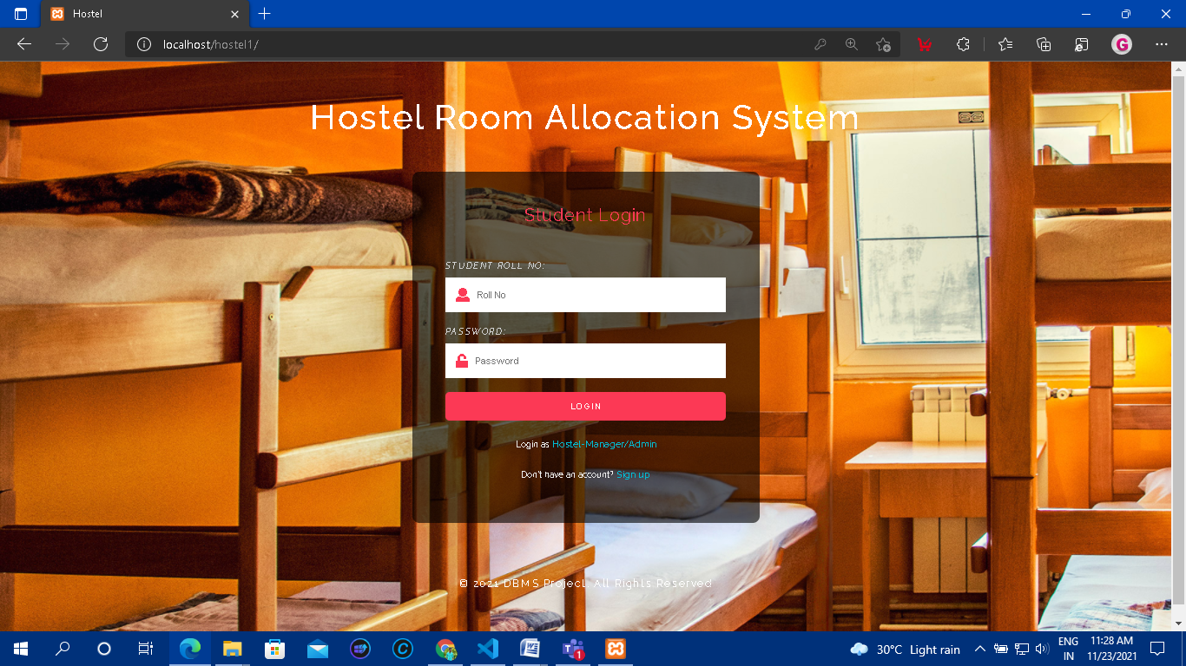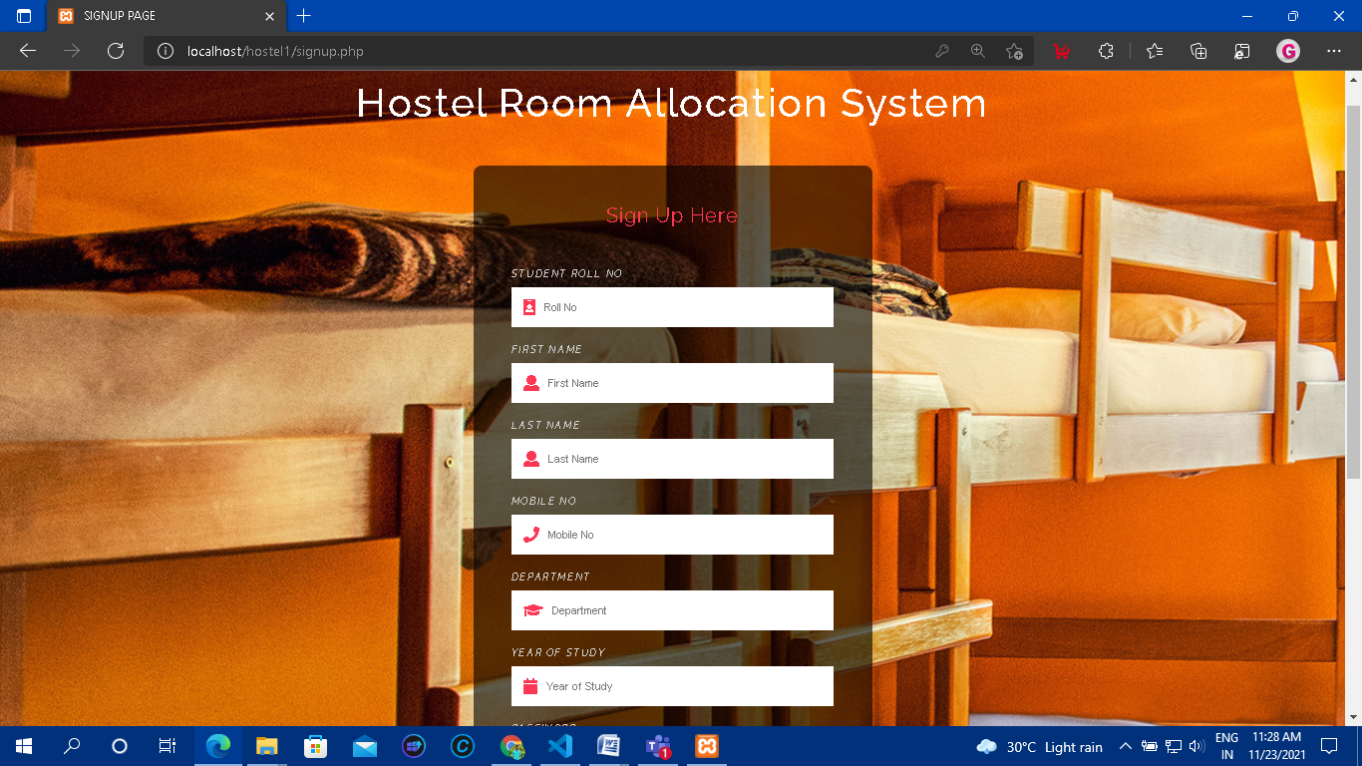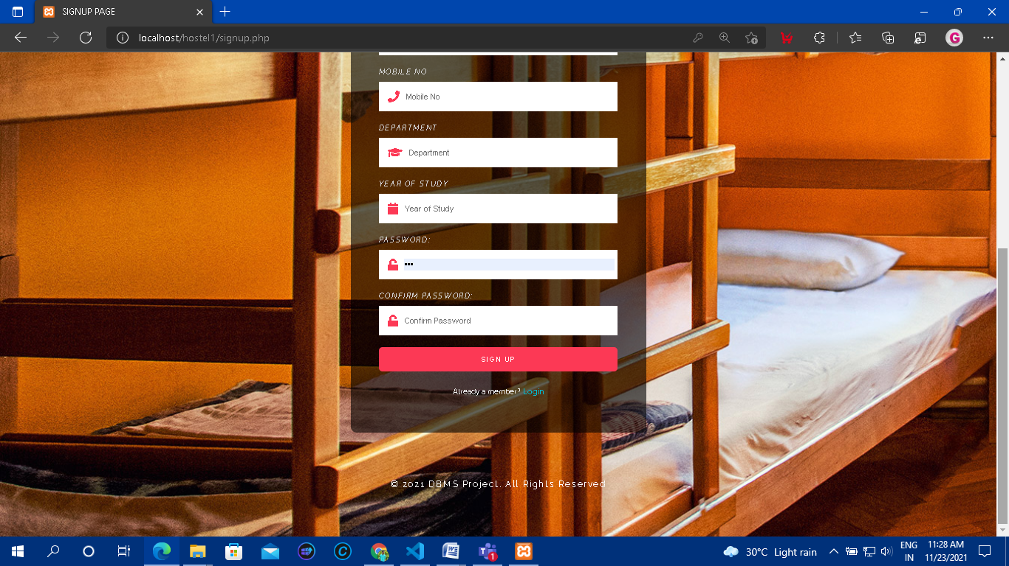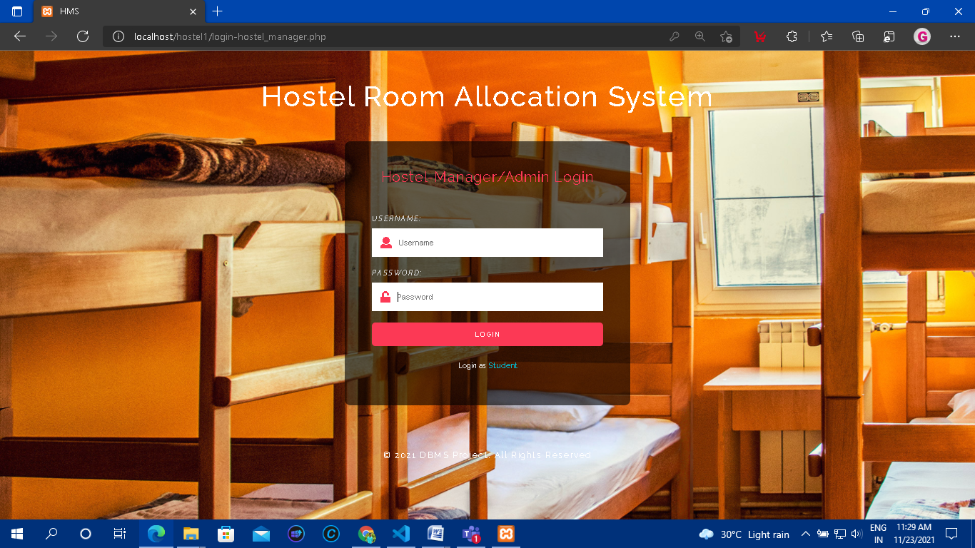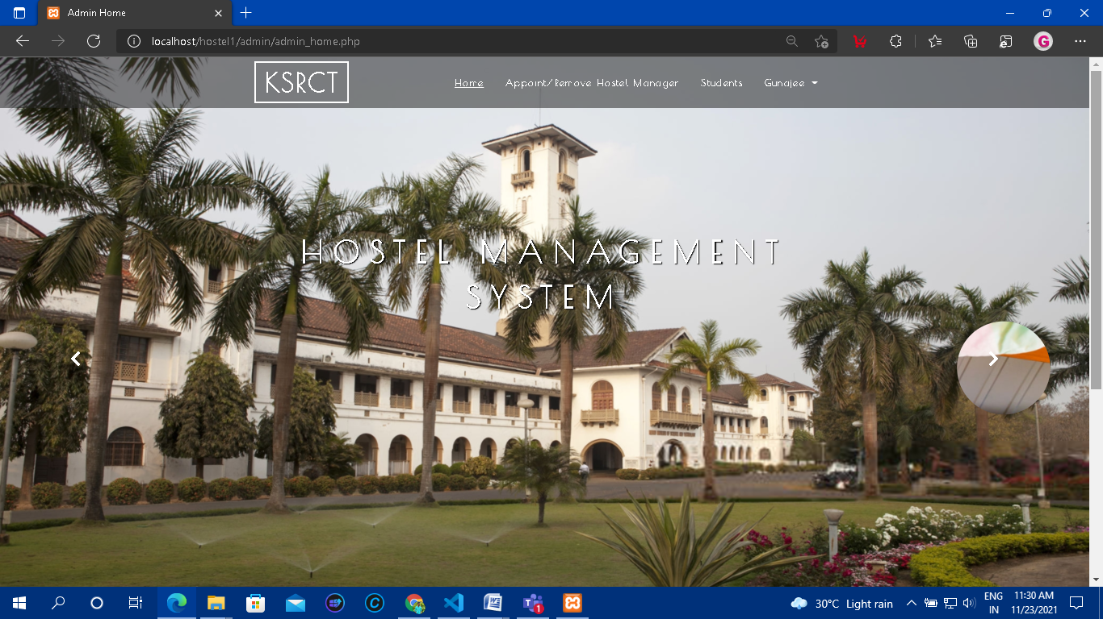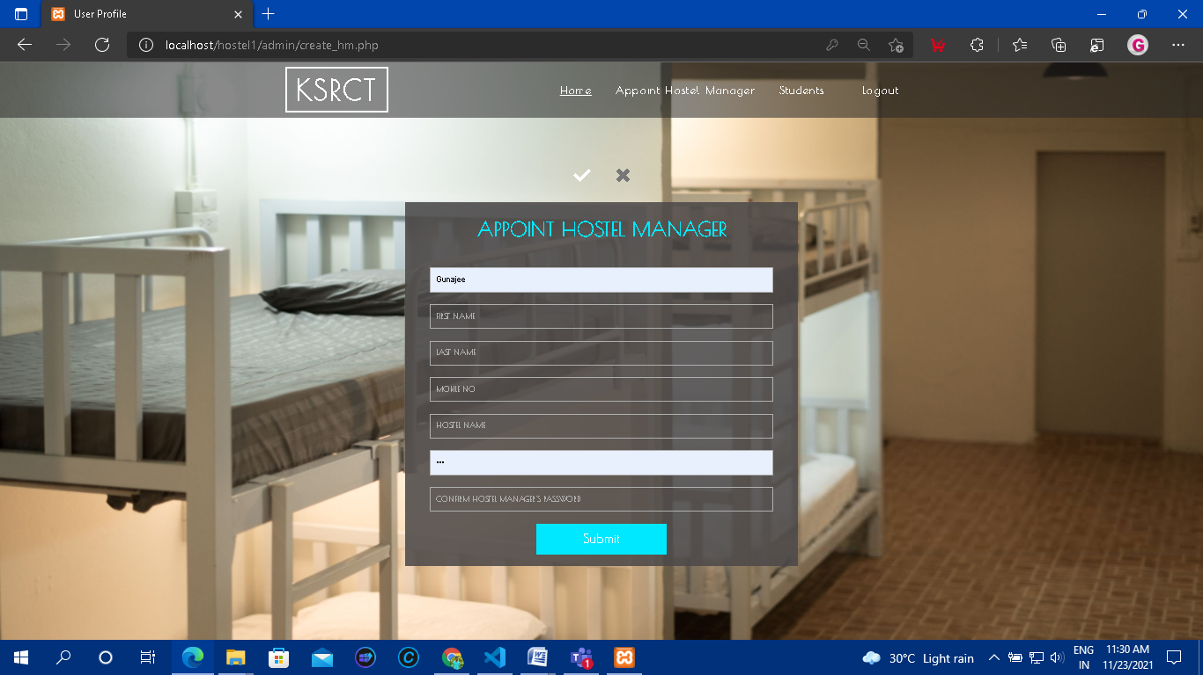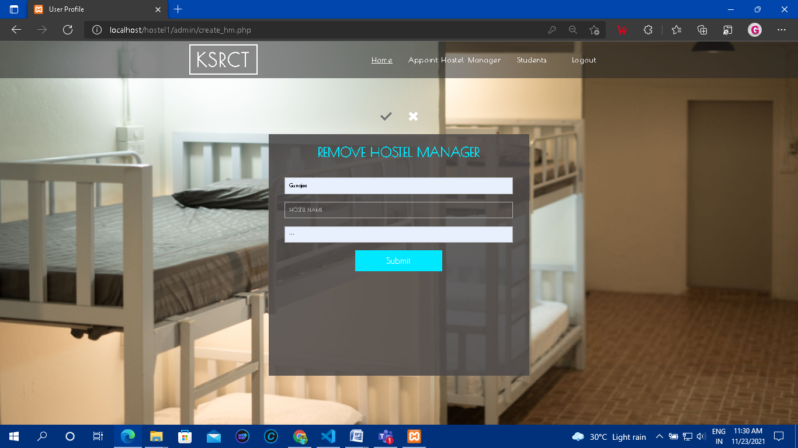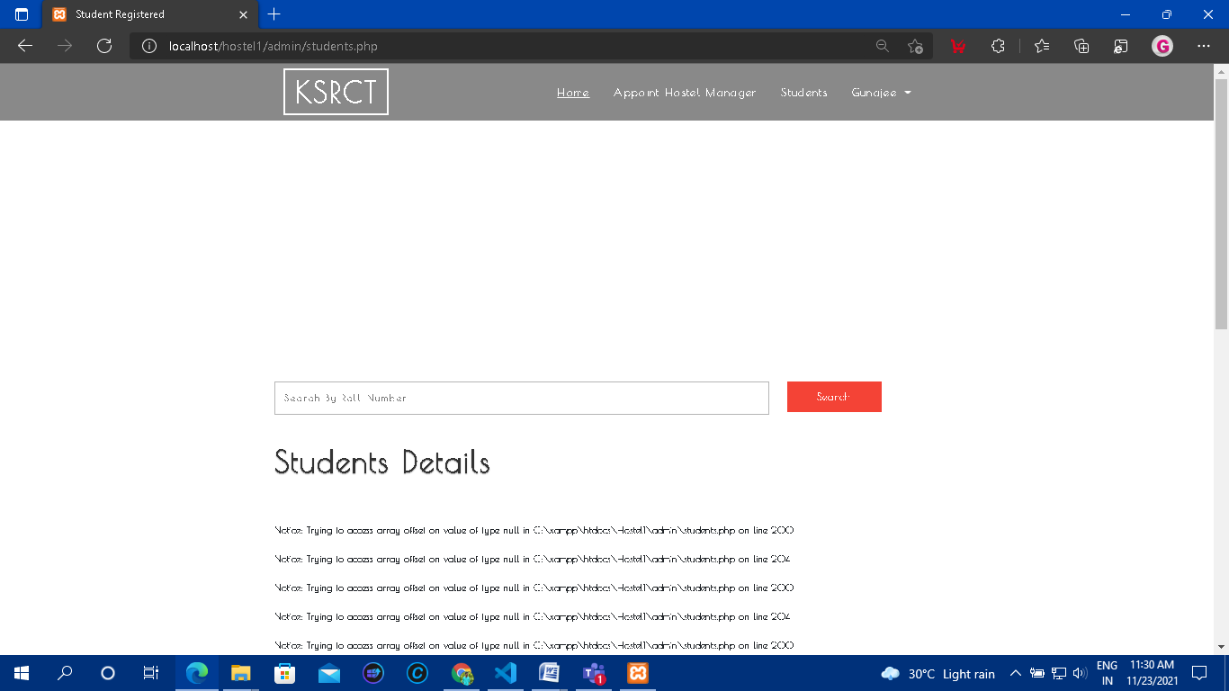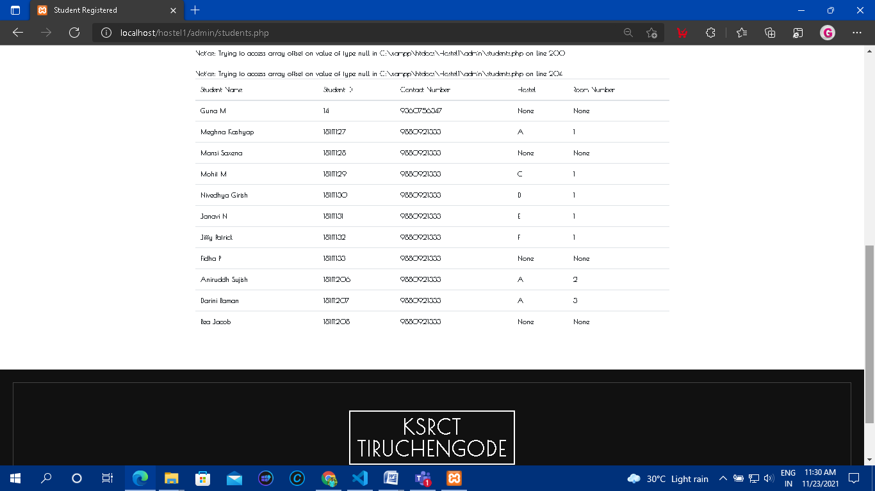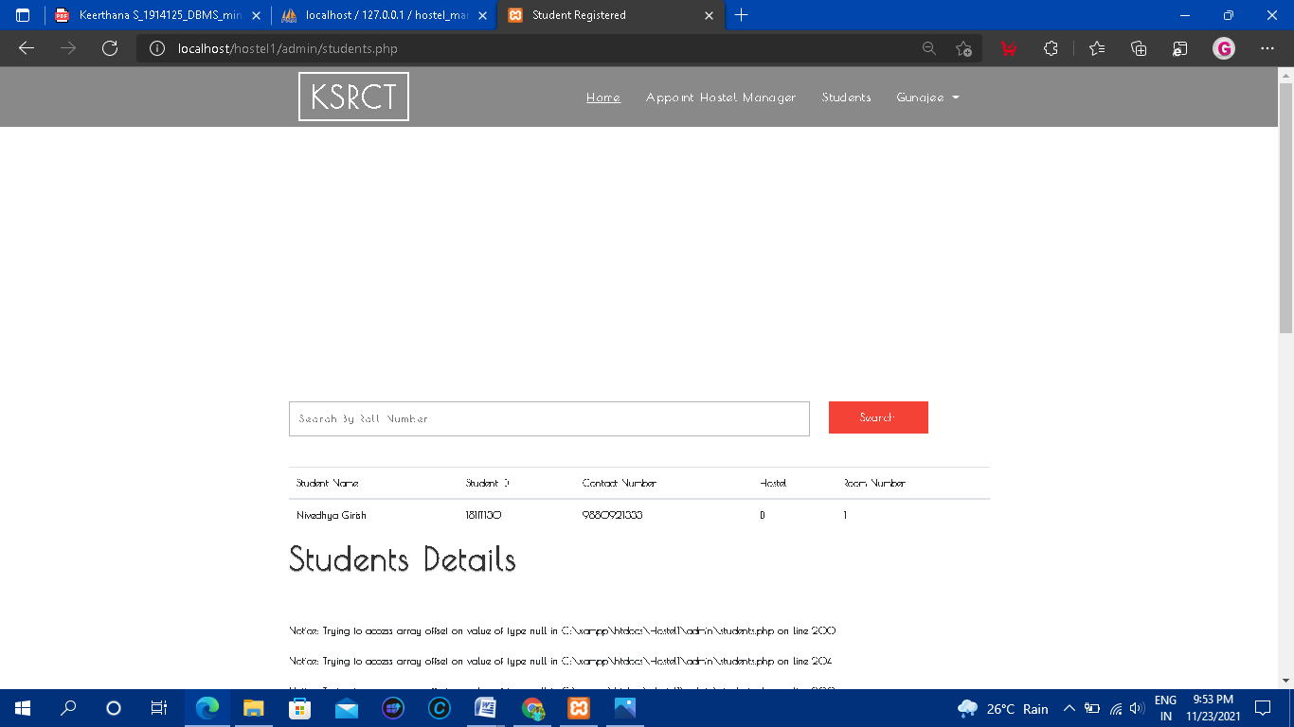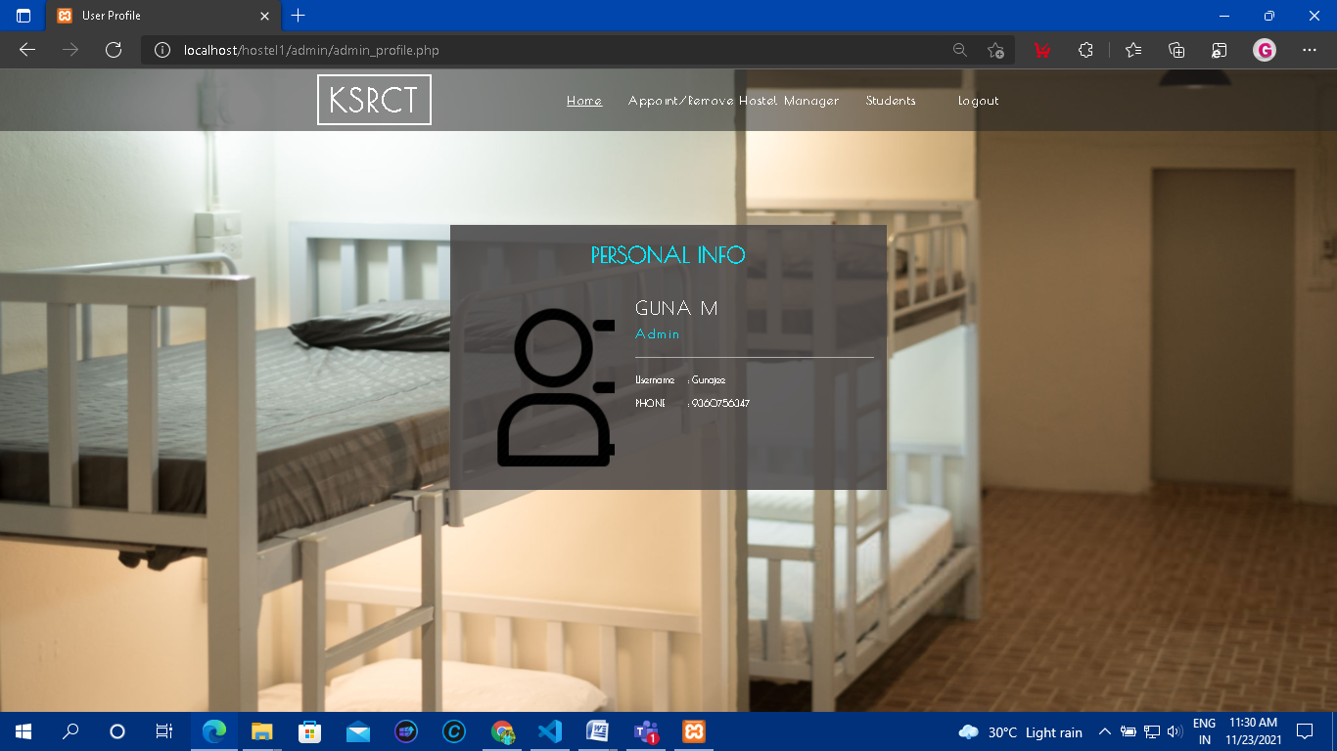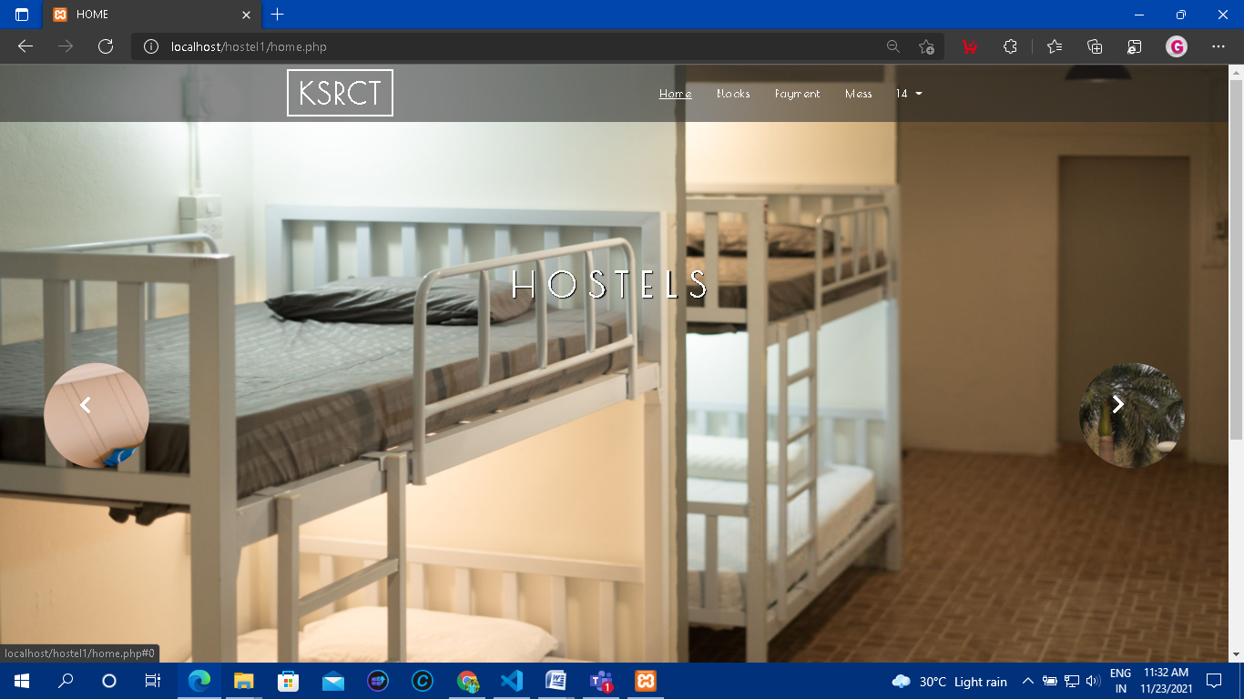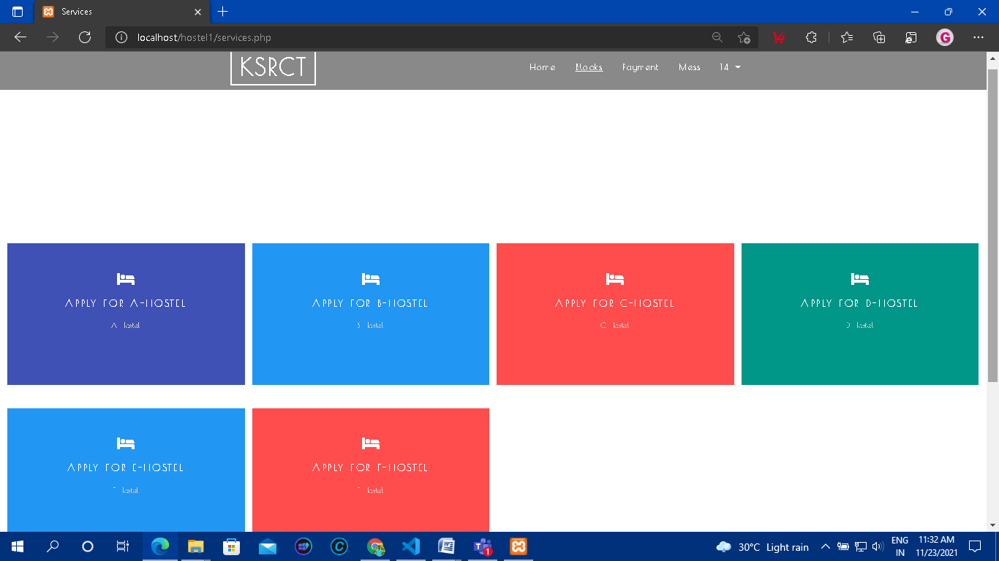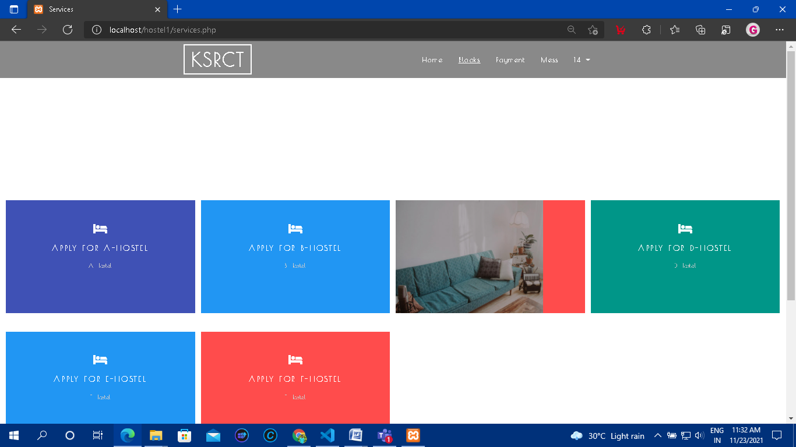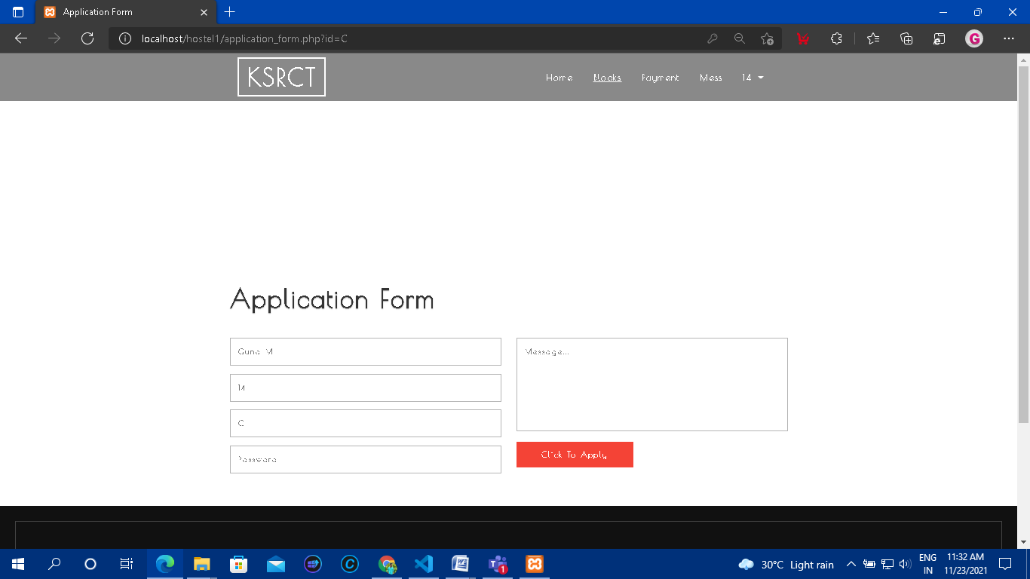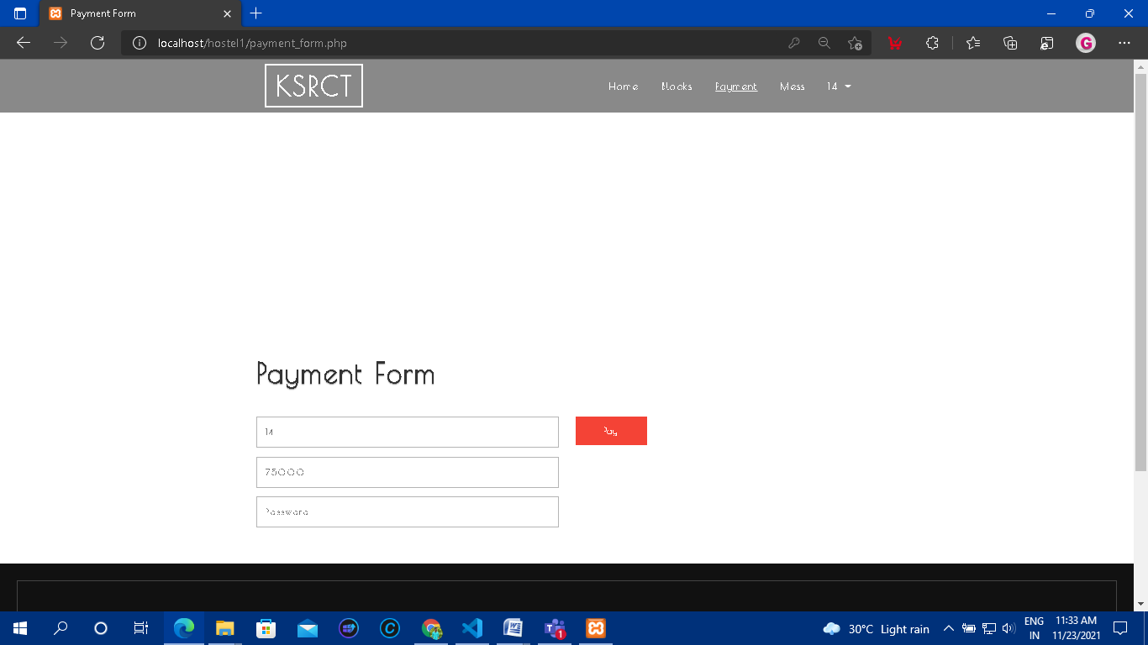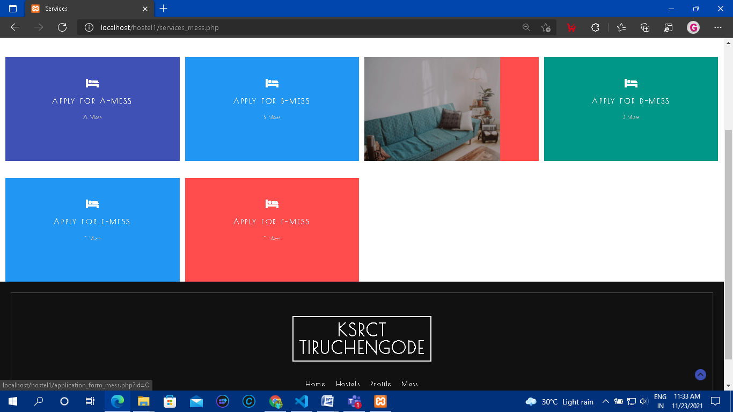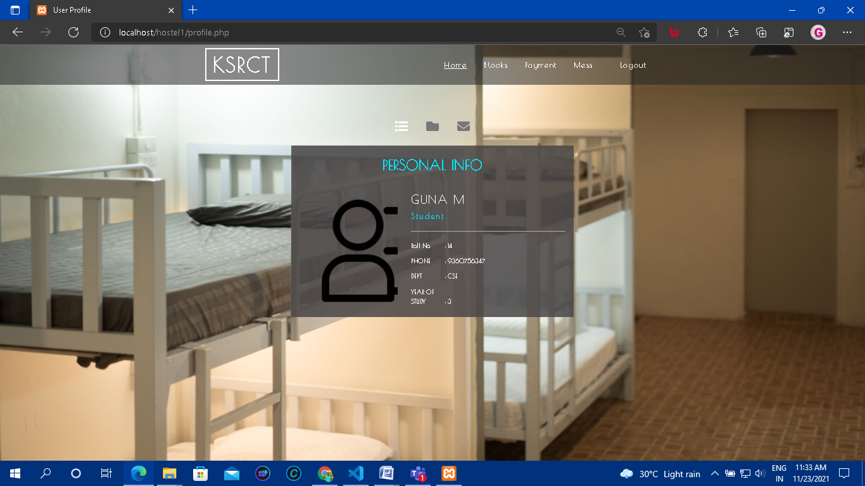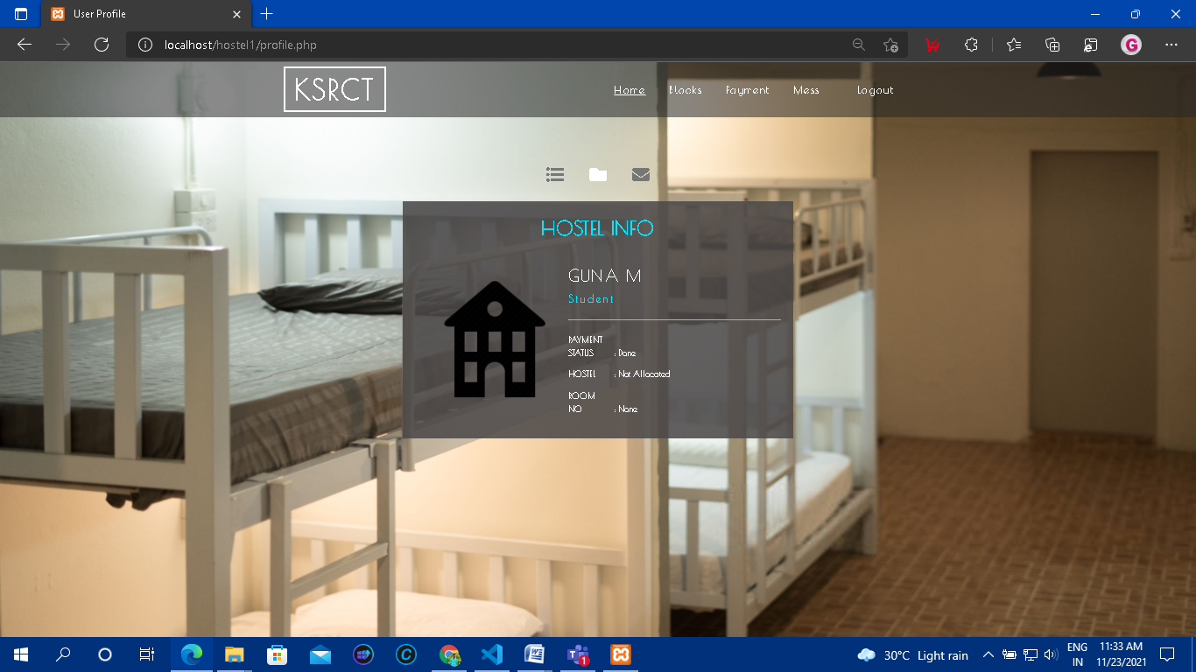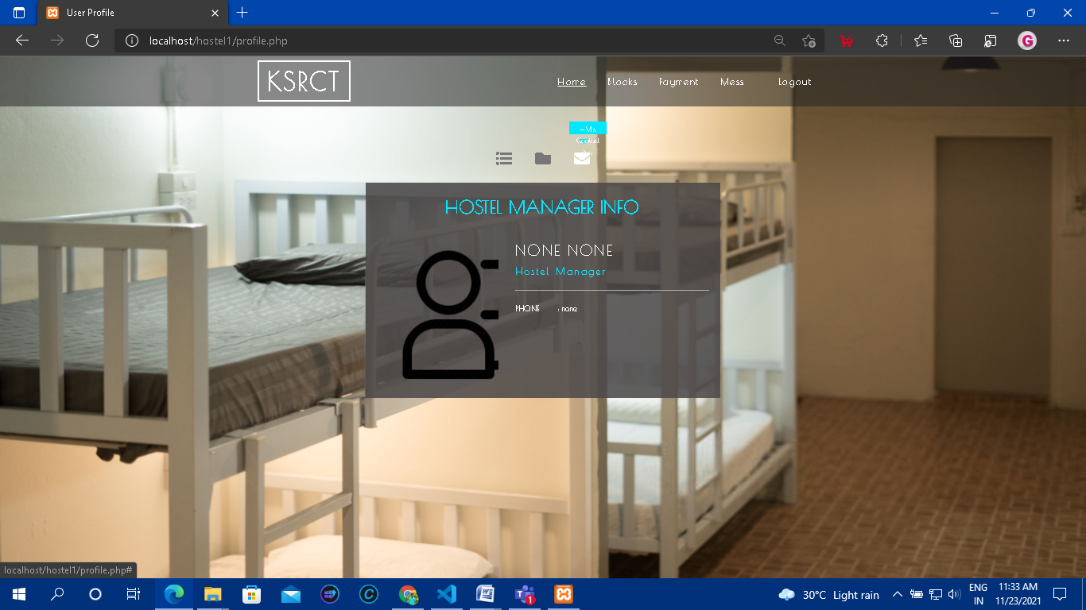

**CHAPTER 4**

**CODING :**

//home.php

<?php

session_start();

require 'includes/config.inc.php';

?>

<!DOCTYPE html>

<html lang="en">

<head>

<title> HOME</title>

<meta name="viewport" content="width=device-width, initial-scale=1">

<meta charset="utf-8">

<meta name="keywords" content="Intrend Responsive web template, Bootstrap Web Templates, Flat Web Templates, Android Compatible web template,

Smartphone Compatible web template, free webdesigns for Nokia, Samsung, LG, SonyEricsson, Motorola web design" />

<script type="application/x-javascript">

addEventListener("load", function () {

setTimeout(hideURLbar, 0);

}, false);

function hideURLbar() {

window.scrollTo(0, 1);

}

</script>

<link href="web_home/css_home/slider.css" type="text/css" rel="stylesheet" media="all">

<!-- css files -->

<link rel="stylesheet" href="web_home/css_home/bootstrap.css"> <!-- Bootstrap-Core-CSS -->

<link rel="stylesheet" href="web_home/css_home/style.css" type="text/css" media="all"/> <!-- Style-CSS -->

<link rel="stylesheet" href="web_home/css_home/fontawesome-all.css"> <!-- Font-Awesome-Icons-CSS -->

<link rel="stylesheet" href="web_home/css_home/flexslider.css" type="text/css" media="screen" property="" /><!-- flexslider css -->

<link href="//fonts.googleapis.com/css?family=Poiret+One&amp;subset=cyrillic,latin-ext" rel="stylesheet">

</head>

<body>

<div class="banner" id="home">

<div class="cd-radial-slider-wrapper">

<header>

<div class="container agile-banner_nav">

<nav class="navbar navbar-expand-lg navbar-light bg-light">

<h1><a class="navbar-brand" href="home.php">KSRCT <span class="display"></span></a></h1>

<button class="navbar-toggler" type="button" data-toggle="collapse" data-target="#navbarSupportedContent" aria-controls="navbarSupportedContent" aria-expanded="false" aria-label="Toggle navigation">

<span class="navbar-toggler-icon"></span>

</button>

<div class="collapse navbar-collapse justify-content-center" id="navbarSupportedContent">

<ul class="navbar-nav ml-auto">

<li class="nav-item active">

<a class="nav-link" href="home.php">Home <span class="sr-only">(current)</span></a>

</li>

<li class="nav-item">

<a class="nav-link" href="services.php">Blocks</a>

</li>

<li class="nav-item">

<a class="nav-link" href="payment_form.php">Payment</a>

</li>

<li class="nav-ite">

<a class="nav-link" href="services_mess.php">Mess</a>

</li>

<li class="dropdown nav-item">

<a href="#" class="dropdown-toggle nav-link" data-toggle="dropdown"><?php echo $_SESSION['roll']; ?>

<b class="caret"></b>

</a>

<ul class="dropdown-menu agile_short_dropdown">

<li>

<a href="profile.php">My Profile</a>

</li>

<li>

<a href="includes/logout.inc.php">Logout</a>

</li>

</ul>

</li>

</ul>

</div>

</nav>

</div>

</header>

<ul class="cd-radial-slider" data-radius1="60" data-radius2="1364" data-centerx1="110" data-centerx2="1290">

<li class="visible">

<div class="svg-wrapper">

<svg viewBox="0 0 1400 800">

<title>Animated SVG</title>

<defs>

<clipPath id="cd-image-1">

<circle id="cd-circle-1" cx="110" cy="400" r="1364"/>

</clipPath>

</defs>

<image height='800px' width="1400px" clip-path="url(#cd-image-1)" xlink:href="web_home/images/1.png"></image>

</svg>

</div> <!-- .svg-wrapper -->

<div class="cd-radial-slider-content">

<div class="wrapper">

<div class="text-center">

<h2>Hostel Management </h2>

<h3> System </h3>

</div>

</div>

</div>

</li>

<li class="next-slide">

<div class="svg-wrapper">

<svg viewBox="0 0 1400 800">

<title>Animated SVG</title>

<defs>

<clipPath id="cd-image-2">

<circle id="cd-circle-2" cx="1290" cy="400" r="60"/>

</clipPath>

</defs>

<image height='800px' width="1400px" clip-path="url(#cd-image-2)" xlink:href="web_home/images/2.png"></image>

</svg>

</div>

<div class="cd-radial-slider-content text-center">

<div class="wrapper">

<div class="text-center">

<h3>Rooms</h3>

</div>

</div>

</div>

</li>

<li>

<div class="svg-wrapper">

<svg viewBox="0 0 1400 800">

<title>Animated SVG</title>

<defs>

<clipPath id="cd-image-3">

<circle id="cd-circle-3" cx="110" cy="400" r="60"/>

</clipPath>

</defs>

<image height='800px' width="1400px" clip-path="url(#cd-image-3)" xlink:href="web_home/images/3.png"></image>

</svg>

</div> <!-- .svg-wrapper -->

<div class="cd-radial-slider-content text-center">

<div class="wrapper">

<div class="text-center">

<h3>Hostels</h3>

</div>

</div>

</div>

</li>

</ul>

<ul class="cd-radial-slider-navigation">

<li><a href="#0" class="next"><i class="fas fa-chevron-right"></i></a></li>

<li><a href="#0" class="prev"><i class="fas fa-chevron-left"></i></a></li>

</ul>

</div>

</div>

<footer class="py-5">

<div class="container py-md-5">

<div class="footer-logo mb-5 text-center">

<a class="navbar-brand" href="http://www.nitk.ac.in/" target="_blank">KSRCT <span class="display"> TIRUCHENGODE</span></a>

</div>

<div class="footer-grid">

<div class="list-footer">

<ul class="footer-nav text-center">

<li>

<a href="home.php">Home</a>

</li>

<li>

<a href="services.php">Blocks</a>

</li>

<li>

<a href="profile.php">Profile</a>

</li>

</ul>

</div>

</div>

</div>

</footer>

<script type="text/javascript" src="web_home/js/jquery-2.2.3.min.js"></script>

<script type="text/javascript" src="web_home/js/bootstrap.js"></script> <!-- Necessary-JavaScript-File-For-Bootstrap -->

<script src="web_home/js/snap.svg-min.js"></script>

<script src="web_home/js/main.js"></script> <!-- Resource jQuery -->

<script defer src="web_home/js/jquery.flexslider.js"></script>

<script type="text/javascript">

$(window).load(function(){

$('.flexslider').flexslider({

animation: "slide",

start: function(slider){

$('body').removeClass('loading');

}

});

});

</script>

<script src="web_home/js/SmoothScroll.min.js"></script>

<script type="text/javascript" src="web_home/js/move-top.js"></script>

<script type="text/javascript" src="web_home/js/easing.js"></script>

<script type="text/javascript">

jQuery(document).ready(function($) {

$(".scroll").click(function(event){

event.preventDefault();

$('html,body').animate({scrollTop:$(this.hash).offset().top},1000);

});

});

</script>

<!-- here stars scrolling icon -->

<script type="text/javascript">

$(document).ready(function() {

/*

var defaults = {

containerID: 'toTop', // fading element id

containerHoverID: 'toTopHover', // fading element hover id

scrollSpeed: 1200,

easingType: 'linear'

};

*/

$().UItoTop({ easingType: 'easeOutQuart' });

});

</script>

</body>

</html>

//login.php

<?php session_start(); ?>

<!DOCTYPE html>

<html lang="en">

<head>

<title>HMS</title>

<meta charset="UTF-8" />

<meta name="viewport" content="width=device-width, initial-scale=1.0" />

<meta name="keywords" content="Art Sign Up Form Responsive Widget, Audio and Video players, Login Form Web Template, Flat Pricing Tables, Flat Drop-Downs, Sign-Up Web Templates,

Flat Web Templates, Login Sign-up Responsive Web Template, Smartphone Compatible Web Template, Free Web Designs for Nokia, Samsung, LG, Sony Ericsson, Motorola Web Design"

/>

<link href="web/css/style.css" rel="stylesheet" type="text/css" />

<link href="web/css/fontawesome-all.css" rel="stylesheet" />

<link href="//fonts.googleapis.com/css?family=Raleway:100,100i,200,200i,300,300i,400,400i,500,500i,600,600i,700,700i,800,800i,900,900i"

rel="stylesheet">

</head>

<body>

<h1>Hostel Room Allocation System</h1>

<div class=" w3l-login-form">

<h2>Hostel-Manager/Admin Login</h2>

<form action="includes/login-hm.inc.php" method="POST">

<div class=" w3l-form-group">

<label>Username:</label>

<div class="group">

<i class="fas fa-user"></i>

<input type="text" class="form-control" name="username" placeholder="Username" required="required" />

</div>

</div>

<div class=" w3l-form-group">

<label>Password:</label>

<div class="group">

<i class="fas fa-unlock"></i>

<input type="password" class="form-control" name="pwd" placeholder="Password" required="required" />

</div>

</div>

<!--<div class="forgot">

<a href="#">Forgot Password?</a>

<p><input type="checkbox">Remember Me</p>

</div>-->

<button type="submit" name="login-submit">Login</button>

</form>

<p class=" w3l-register-p">Login as<a href="index.php" class="register"> Student</a></p>

<!-- <p class=" w3l-register-p">Don't have an account?<a href="signup.php" class="register"> Sign up</a></p>-->

</div>

<footer>

<p class="copyright-agileinfo"> &copy; 2021 DBMS Project. All Rights Reserved </p>

</footer>

</body>

</html>

//index.php

<?php session_start(); ?>

<!DOCTYPE html>

<html lang="en">

<head>

<title>Hostel</title>

<meta charset="UTF-8" />

<meta name="viewport" content="width=device-width, initial-scale=1.0" />

<meta name="keywords" content="Art Sign Up Form Responsive Widget, Audio and Video players, Login Form Web Template, Flat Pricing Tables, Flat Drop-Downs, Sign-Up Web Templates,

Flat Web Templates, Login Sign-up Responsive Web Template, Smartphone Compatible Web Template, Free Web Designs for Nokia, Samsung, LG, Sony Ericsson, Motorola Web Design"

/>

<link href="web/css/style.css" rel="stylesheet" type="text/css" />

<link href="web/css/fontawesome-all.css" rel="stylesheet" />

<link href="//fonts.googleapis.com/css?family=Raleway:100,100i,200,200i,300,300i,400,400i,500,500i,600,600i,700,700i,800,800i,900,900i"

rel="stylesheet">

</head>

<body>

<h1>Hostel Room Allocation System</h1>

<div class=" w3l-login-form">

<h2>Student Login</h2>

<form action="includes/login.inc.php" method="POST">

<div class=" w3l-form-group">

<label>Student Roll No:</label>

<div class="group">

<i class="fas fa-user"></i>

<input type="text" class="form-control" name="student_roll_no" placeholder="Roll No" required="required" />

</div>

</div>

<div class=" w3l-form-group">

<label>Password:</label>

<div class="group">

<i class="fas fa-unlock"></i>

<input type="password" class="form-control" name="pwd" placeholder="Password" required="required" />

</div>

</div>

<!--<div class="forgot">

<a href="#">Forgot Password?</a>

<p><input type="checkbox">Remember Me</p>

</div>-->

<button type="submit" name="login-submit">Login</button>

</form>

<p class=" w3l-register-p">Login as<a href="login-hostel_manager.php" class="register"> Hostel-Manager/Admin</a></p>

<p class=" w3l-register-p">Don't have an account?<a href="signup.php" class="register"> Sign up</a></p>

</div>

<footer>

<p class="copyright-agileinfo"> &copy; 2021 DBMS Project. All Rights Reserved</p>

</footer>

</body>

</html>

//signup.php

<?php session_start(); ?>

<!DOCTYPE html>

<html lang="en">

<head>

<title>SIGNUP PAGE</title>

<meta charset="UTF-8" />

<meta name="viewport" content="width=device-width, initial-scale=1.0" />

<meta name="keywords" content="Art Sign Up Form Responsive Widget, Audio and Video players, Login Form Web Template, Flat Pricing Tables, Flat Drop-Downs, Sign-Up Web Templates,

Flat Web Templates, Login Sign-up Responsive Web Template, Smartphone Compatible Web Template, Free Web Designs for Nokia, Samsung, LG, Sony Ericsson, Motorola Web Design"

/>

<link href="web/css/style.css" rel="stylesheet" type="text/css" />

<link href="web/css/fontawesome-all.css" rel="stylesheet" />

<link href="//fonts.googleapis.com/css?family=Raleway:100,100i,200,200i,300,300i,400,400i,500,500i,600,600i,700,700i,800,800i,900,900i"

rel="stylesheet">

</head>

<body>

<h1>Hostel Room Allocation System</h1>

<div class=" w3l-login-form">

<h2>Sign Up Here</h2>

<form action="includes/signup.inc.php" method="POST">

<div class=" w3l-form-group">

<label>Student Roll No</label>

<div class="group">

<i class="fas fa-id-badge"></i>

<input type="text" class="form-control" name="student_roll_no" placeholder="Roll No" required="required" />

</div>

</div>

<div class=" w3l-form-group">

<label>First Name</label>

<div class="group">

<i class="fas fa-user"></i>

<input type="text" class="form-control" name="student_fname" placeholder="First Name" required="required" />

</div>

</div>

<div class=" w3l-form-group">

<label>Last Name</label>

<div class="group">

<i class="fas fa-user"></i>

<input type="text" class="form-control" name="student_lname" placeholder="Last Name" required="required" />

</div>

</div>

<div class=" w3l-form-group">

<label>Mobile No</label>

<div class="group">

<i class="fas fa-phone"></i>

<input type="text" class="form-control" name="mobile_no" placeholder="Mobile No" required="required" />

</div>

</div>

<div class=" w3l-form-group">

<label>Department</label>

<div class="group">

<i class="fas fa-graduation-cap"></i>

<input type="text" class="form-control" name="department" placeholder="Department" required="required" />

</div>

</div>

<div class=" w3l-form-group">

<label>Year of Study</label>

<div class="group">

<i class="fas fa-calendar"></i>

<input type="text" class="form-control" name="year_of_study" placeholder="Year of Study" required="required" />

</div>

</div>

<!-- <div class=" w3l-form-group">

<label>Email:</label>

<div class="group">

<i class="fas fa-envelope"></i>

<input type="text" class="form-control" name="mail" placeholder="Email" required="required" />

</div>

</div>-->

<div class=" w3l-form-group">

<label>Password:</label>

<div class="group">

<i class="fas fa-unlock"></i>

<input type="password" class="form-control" name="pwd" placeholder="Password" required="required" https://github.com/veenanitk/DBMS-Project.git/>

</div>

</div>

<div class=" w3l-form-group">

<label>Confirm Password:</label>

<div class="group">

<i class="fas fa-unlock"></i>

<input type="password" class="form-control" name="confirmpwd" placeholder="Confirm Password" required="required" />

</div>

</div>

<!--<div class="forgot">

<a href="#">Forgot Password?</a>

<p><input type="checkbox">Remember Me</p>

</div>-->

<button type="submit" name="signup-submit">Sign Up</button>

</form>

<p class=" w3l-register-p">Already a member?<a href="index.php" class="register"> Login</a></p>

</div>

<footer>

<p class="copyright-agileinfo"> &copy; 2021 DBMS Project. All Rights Reserved </p>

</footer>

</body>

</html>

href="includes/logout.inc.php">Logout</a>

</li>

</ul>

</li>

</ul>

</div>

</nav>

</div>

</header>

<!--Header-->

</div>

<!-- //banner -->

<br><br><br>

<section class="contact py-5">

<div class="container">

<div class="mail_grid_w3l">

<form action="allocated_mess_card.php" method="post">

<div class="row">

<div class="col-md-9">

<input type="text" placeholder="Search by Roll Number" name="search_box">

</div>

<div class="col-md-3">

<input type="submit" value="Search" name="search"></input>

</div>

</div>

</form>

</div>

</div>

</section>

<?php

if (isset($_POST['search'])) {

$search_box = $_POST['search_box'];

$mess_id = $_SESSION['Mess_id'];

$query_search = "SELECT * FROM Student WHERE Student_id like '$search_box%' and Mess_id = '$mess_id'";

$result_search = mysqli_query($conn,$query_search);

//select the mess name from mess table

$query6 = "SELECT * FROM Mess WHERE Mess_id = '$mess_id'";

$result6 = mysqli_query($conn,$query6);

$row6 = mysqli_fetch_assoc($result6);

$mess_name = $row6['Mess_name'];

?>

<div class="container">

<table class="table table-hover">

<thead>

<tr>

<th>Student Name</th>

<th>Roll No</th>

<th>Contact Number</th>

<th>Mess</th>

<th>Mess card Number</th>

</tr>

</thead>

<tbody>

<?php

if(mysqli_num_rows($result_search)==0){

echo '<tr><td colspan="4">No Rows Returned</td></tr>';

}

else{

while($row_search = mysqli_fetch_assoc($result_search)){

//get the name of the student to display

$mess_card_id = $row_search['Mess_card_id'];

$query7 = "SELECT * FROM Mess_Allocation WHERE Mess_card_id = '$mess_card_id'";

$result7 = mysqli_query($conn,$query7);

$row7 = mysqli_fetch_assoc($result7);

$mess_card_no = $row7['Mess_card_No'];

//student name

$student_name = $row_search['Fname']." ".$row_search['Lname'];

echo "<tr><td>{$student_name}</td><td>{$row_search['Student_id']}</td><td>{$row_search['Mob_no']}</td><td>{$mess_name}</td><td>{$mess_card_no}</td></tr>\n";

}

}

?>

</tbody>

</table>

</div>

<?php

}

?>

<div class="container">

<h2 class="heading text-capitalize mb-sm-5 mb-4"> Mess Allotted </h2>

<?php

$mess_id = $_SESSION['Mess_id'];

$query1 = "SELECT * FROM Student where Mess_id = '$mess_id'";

$result1 = mysqli_query($conn,$query1);

//select the mess name from mess table

$query6 = "SELECT * FROM Mess WHERE Mess_id = '$mess_id'";

$result6 = mysqli_query($conn,$query6);

$row6 = mysqli_fetch_assoc($result6);

$mess_name = $row6['Mess_name'];

?>

<table class="table table-hover">

<thead>

<tr>

<th>Student Name</th>

<th>Roll No</th>

<th>Contact Number</th>

<th>Mess</th>

<th>Mess card Number</th>

</tr>

</thead>

<tbody>

<?php

if(mysqli_num_rows($result1)==0){

echo '<tr><td colspan="4">No Rows Returned</td></tr>';

}

else{

while($row1 = mysqli_fetch_assoc($result1)){

//get the mess_card_no of the student from mess_card_id in Mess_Allocation table

$mess_card_id = $row1['Mess_card_id'];

$query7 = "SELECT * FROM Mess_Allocation WHERE Mess_card_id = '$mess_card_id'";

$result7 = mysqli_query($conn,$query7);

$row7 = mysqli_fetch_assoc($result7);

$mess_card_no = $row7['Mess_card_No'];

//student name

$student_name = $row1['Fname']." ".$row1['Lname'];

echo "<tr><td>{$student_name}</td><td>{$row1['Student_id']}</td><td>{$row1['Mob_no']}</td><td>{$mess_name}</td><td>{$mess_card_no}</td></tr>\n";

}

}

?>

</tbody>

</table>

</div>

<br>

<br>

<br>

<footer class="py-5">

<div class="container py-md-5">

<div class="footer-logo mb-5 text-center">

<a class="navbar-brand" href="http://www.nitk.ac.in/" target="_blank">KSRCT <span class="display"> SURATHKAL</span></a>

</div>

<div class="footer-grid">

<div class="list-footer">

<ul class="footer-nav text-center">

<li>

<a href="home_manager.php">Home</a>

</li>

<li>

<a href="allocate_mess_card.php">Allocate</a>

</li>

<li>

<a href="admin/manager_profile.php">Profile</a>

</li>

</ul>

</div>

</div>

</div>

</footer>

<script type="text/javascript" src="web_home/js/jquery-2.2.3.min.js"></script>

<script type="text/javascript" src="web_home/js/bootstrap.js"></script>

<script src="web_home/js/snap.svg-min.js"></script>

<script src="web_home/js/main.js"></script> <!-- Resource jQuery -->

<script defer src="web_home/js/jquery.flexslider.js"></script>

<script type="text/javascript">

$(window).load(function(){

$('.flexslider').flexslider({

animation: "slide",

start: function(slider){

$('body').removeClass('loading');

}

});

});

</script>

<script src="web_home/js/SmoothScroll.min.js"></script>

<script type="text/javascript" src="web_home/js/move-top.js"></script>

<script type="text/javascript" src="web_home/js/easing.js"></script>

<script type="text/javascript">

jQuery(document).ready(function($) {

$(".scroll").click(function(event){

event.preventDefault();

$('html,body').animate({scrollTop:$(this.hash).offset().top},1000);

});

});

</script>

<!-- here stars scrolling icon -->

<script type="text/javascript">

$(document).ready(function() {

$().UItoTop({ easingType: 'easeOutQuart' });

});

</script>

</body>

</html>

//admin_home.php

<?php

session_start();

require '../includes/config.inc.php';

?>

<!DOCTYPE html>

<html lang="en">

<head>

<title> Admin Home</title>

<meta name="viewport" content="width=device-width, initial-scale=1">

<meta charset="utf-8">

<meta name="keywords" content="Intrend Responsive web template, Bootstrap Web Templates, Flat Web Templates, Android Compatible web template,

Smartphone Compatible web template, free webdesigns for Nokia, Samsung, LG, SonyEricsson, Motorola web design" />

<script type="application/x-javascript">

addEventListener("load", function () {

setTimeout(hideURLbar, 0);

}, false);

function hideURLbar() {

window.scrollTo(0, 1);

}

</script>

<link href="../web_home/css_home/slider.css" type="text/css" rel="stylesheet" media="all">

<link rel="stylesheet" href="../web_home/css_home/bootstrap.css"> <!-- Bootstrap-Core-CSS -->

<link rel="stylesheet" href="../web_home/css_home/style.css" type="text/css" media="all" /> <!-- Style-CSS -->

<link rel="stylesheet" href="../web_home/css_home/fontawesome-all.css"> <!-- Font-Awesome-Icons-CSS -->

<link rel="stylesheet" href="../web_home/css_home/flexslider.css" type="text/css" media="screen" property="" /><!-- flexslider css -->

<link href="//fonts.googleapis.com/css?family=Poiret+One&amp;subset=cyrillic,latin-ext" rel="stylesheet">

</head>

<body>

<div class="banner" id="home">

<div class="cd-radial-slider-wrapper">

<header>

<div class="container agile-banner_nav">

<nav class="navbar navbar-expand-lg navbar-light bg-light">

<h1><a class="navbar-brand" href="admin_home.php">KSRCT <span class="display"></span></a></h1>

<button class="navbar-toggler" type="button" data-toggle="collapse" data-target="#navbarSupportedContent" aria-controls="navbarSupportedContent" aria-expanded="false" aria-label="Toggle navigation">

<span class="navbar-toggler-icon"></span>

</button>

<div class="collapse navbar-collapse justify-content-center" id="navbarSupportedContent">

<ul class="navbar-nav ml-auto">

<li class="nav-item active">

<a class="nav-link" href="admin_home.php">Home <span class="sr-only">(current)</span></a>

</li>

<li class="nav-item">

<a class="nav-link" href="create_hm.php">Appoint/Remove Hostel Manager</a>

</li>

<li class="nav-item">

<a class="nav-link" href="students.php">Students</a>

</li>

<li class="dropdown nav-item">

<a href="#" class="dropdown-toggle nav-link" data-toggle="dropdown"><?php echo $_SESSION['username']; ?>

<b class="caret"></b>

</a>

<ul class="dropdown-menu agile_short_dropdown">

<li>

<a href="admin_profile.php">My Profile</a>

</li>

<li>

<a href="../includes/logout.inc.php">Logout</a>

</li>

</ul>

</li>

</ul>

</div>

</nav>

</div>

</header>

<ul class="cd-radial-slider" data-radius1="60" data-radius2="1364" data-centerx1="110" data-centerx2="1290">

<li class="visible">

<div class="svg-wrapper">

<svg viewBox="0 0 1400 800">

<title>Animated SVG</title>

<defs>

<clipPath id="cd-image-1">

<circle id="cd-circle-1" cx="110" cy="400" r="1364"/>

</clipPath>

</defs>

<image height='800px' width="1400px" clip-path="url(#cd-image-1)" xlink:href="../web_home/images/1.png"></image>

</svg>

</div> <!-- .svg-wrapper -->

<div class="cd-radial-slider-content">

<div class="wrapper">

<div class="text-center">

<h2>Hostel Management </h2>

<h3> System </h3>

</div>

</div>

</div>

</li>

<li class="next-slide">

<div class="svg-wrapper">

<svg viewBox="0 0 1400 800">

<title>Animated SVG</title>

<defs>

<clipPath id="cd-image-2">

<circle id="cd-circle-2" cx="1290" cy="400" r="60"/>

</clipPath>

</defs>

<image height='800px' width="1400px" clip-path="url(#cd-image-2)" xlink:href="../web_home/images/2.png"></image>

</svg>

</div>

<div class="cd-radial-slider-content text-center">

<div class="wrapper">

<div class="text-center">

<h3>Rooms</h3>

</div>

</div>

</div>

</li>

<li>

<div class="svg-wrapper">

<svg viewBox="0 0 1400 800">

<title>Animated SVG</title>

<defs>

<clipPath id="cd-image-3">

<circle id="cd-circle-3" cx="110" cy="400" r="60"/>

</clipPath>

</defs>

<image height='800px' width="1400px" clip-path="url(#cd-image-3)" xlink:href="../web_home/images/3.png"></image>

</svg>

</div> <!-- .svg-wrapper -->

<div class="cd-radial-slider-content text-center">

<div class="wrapper">

<div class="text-center">

<h3>Hostels </h3>

</div>

</div>

</div> <!-- .cd-radial-slider-content -->

</li>

</ul> <!-- .cd-radial-slider -->

<ul class="cd-radial-slider-navigation">

<li><a href="#0" class="next"><i class="fas fa-chevron-right"></i></a></li>

<li><a href="#0" class="prev"><i class="fas fa-chevron-left"></i></a></li>

</ul> <!-- .cd-radial-slider-navigation -->

</div> <!-- .cd-radial-slider-wrapper -->

</div>

<footer class="py-5">

<div class="container py-md-5">

<div class="footer-logo mb-5 text-center">

<a class="navbar-brand" href="http://www.nitk.ac.in/" target="_blank">KSRCT<span class="display"> TIRUCHENGODE</span></a>

</div>

<div class="footer-grid">

<div class="list-footer">

<ul class="footer-nav text-center">

<li>

<a href="admin_home.php">Home</a>

</li>

<li>

<a href="create_hm.php">Appoint</a>

</li>

<li>

<a href="students.php">Student</a>

</li>

<li>

<a href="admin_profile.php">Profile</a>

</li>

</ul>

</div>

</div>

</div>

</footer>

<script type="text/javascript" src="../web_home/js/jquery-2.2.3.min.js"></script>

<script type="text/javascript" src="../web_home/js/bootstrap.js"></script> <!-- Necessary-JavaScript-File-For-Bootstrap -->

<script src="../web_home/js/snap.svg-min.js"></script>

<script src="../web_home/js/main.js"></script> <!-- Resource jQuery -->

<script defer src="../web_home/js/jquery.flexslider.js"></script>

<script type="text/javascript">

$(window).load(function(){

$('.flexslider').flexslider({

animation: "slide",

start: function(slider){

$('body').removeClass('loading');

}

});

});

</script>

<script src="../web_home/js/SmoothScroll.min.js"></script>

<script type="text/javascript" src="../web_home/js/move-top.js"></script>

<script type="text/javascript" src="../web_home/js/easing.js"></script>

<script type="text/javascript">

jQuery(document).ready(function($) {

$(".scroll").click(function(event){

event.preventDefault();

$('html,body').animate({scrollTop:$(this.hash).offset().top},1000);

});

});

</script>

<script type="text/javascript">

$(document).ready(function() {

$().UItoTop({ easingType: 'easeOutQuart' });

});

</script>

</body>

</html>

**CHAPTER-5**

**CONCLUSION:**

This project made by the handwork of me and is a small effort in the development of larger programs, and it involves limited aspects which are needed in day to day hostel operation.

The software development although is a very difficult task but it can be carried out successfully with the effort of my work. After the completion of this project we learnt different things about software and its development. I also learnt to work in a group and realize its importance.

Thus this project can be a guideline for the beginners and can be example for the development of a small program.